Liberal Gothic: An Analytical Report
Executive Summary. “Liberal gothic” is a proposed narrative mode marked by educated, often progressive protagonists who foreground personal trauma and existential malaise in hushed, introspective settings. Unlike classical Gothic (emphasis on supernatural terror and architecture[1]) or Southern Gothic (Mid-20th-century U.S. tales of decay and racial legacy[2]), liberal gothic narratives use ordinary liminal spaces (e.g. forests, empty homes) and realistic dialogue to stage emotional confessionals. Plots largely serve as pretexts for interior reflection (what one critic calls “trauma dumping”[3]), rather than delivering external thrills. This report rigorously defines the mode, compares it to related genres, and exemplifies it with 12 case studies (4 novels, 4 films/TV, 4 games). We examine protagonist profiles, tone, narrative function, aesthetics, and political valence, tabulate contrasts with Southern Gothic, classical Gothic, and “prestige indie” works, and discuss cultural implications (including critiques of “trauma culture”[3]). Citations are provided from academic and journalistic sources, reviews, and creators.

Definition and Subtypes of Liberal Gothic
Definition. Liberal gothic is not a historical label but a conceptual one: it denotes works that fuse Gothic moods of alienation and dread with a progressive/liberal sensibility of psychological introspection. The protagonists tend to be middle-class or academic (“professional-managerial class”[3]), often urban or suburban, and their crises revolve around personal grief, guilt, or identity rather than external monsters. The emotional tone is confessional and cathartic – stories feel like therapy sessions or open diaries. As one critic puts it, modern indie narratives are “some of the most thoughtful meditations on … love, loss, and grief”[4]. Aesthetically, liberal gothic uses mundane or empty spaces (remote woods, an abandoned house, a quiet city street at dusk) suffused with ambient dread and detailed realism. The dialogue and narration are conversational, often overlapping with the characters’ inner monologue, rather than stylized gothic archaisms. In sum, liberal gothic recasts the Gothic tradition’s fascination with haunting into a focus on the haunting persistence of trauma and doubt in the psyche[1][3].
Relation to Other Modes. Traditional Gothic (18th–19th c.) centers on fear of the supernatural or uncanny – castles, ghosts, monsters – and moral certainties (good vs evil)[1]. Southern Gothic (20th c.) translates some Gothic tropes to the American South: decaying plantation homes, grotesque characters, and the legacy of slavery and patriarchy[2]. In contrast, liberal gothic typically dispenses with overt horror tropes; its “monsters” are internal (mental illness, grief, alienation) and its spaces are contemporary. It overlaps with the prestige-indie aesthetic (independent art-house narratives) by treating character psychology as the main attraction, but unlike some “indie melancholy,” it often carries an explicit progressive subtext – e.g. foregrounding mental health or social critique – even if subtly.
Taxonomy of Subtypes. Within liberal gothic we can identify sub-genres by setting or focus, for example:
- Domestic/Urban Gothic: Confessional dramas set in everyday environments (city apartments, offices, college campuses). Protagonists unpack personal histories or family secrets. (Examples: A Little Life, Eleanor Oliphant is Completely Fine).
- Wilderness/Liminal Gothic: Stories in rural or isolated settings (forests, mountains, lakes, motels) that externalize inner turmoil. (Examples: Firewatch, What Remains of Edith Finch).
- Youth/Ghost Gothic: Coming-of-age tales with supernatural or uncanny motifs (ghosts, portals) used as metaphors for adolescent trauma. (Examples: Extremely Loud & Incredibly Close, A Ghost Story).
- Techno/AI Gothic: Near-future or technological settings where characters form uncanny relationships (e.g. with an AI) that probe loneliness. (Example: Her).
Each subtype shares the core trait: the plot exists mainly to trigger the character’s internal catharsis. As one game analyst notes for Firewatch, its various mysteries “don’t matter as much as the core relationship between Henry and Delilah”[5]. In liberal-gothic narratives, even conspiracies and supernatural elements often remain secondary to the protagonists’ emotional journeys.

Example Works (Literature, Film/TV, Games)
Literature (4 examples):
- A Little Life (Hanya Yanagihara, 2015) – Follows four friends from elite college into adulthood, focusing on one (Jude) with horrific childhood trauma. The novel is notorious for its unrelenting depiction of suffering. Reviewers describe it as a “brutal, heavy, uncomfortable” read about “friendship, suffering, and the effects of trauma”[6][7]. It centers on white, cultured New Yorkers grappling with self-inflicted pain and guilt, epitomizing the liberal-gothic hero (educated, introspective) whose internal collapse is the point.
- Extremely Loud & Incredibly Close (Jonathan Safran Foer, 2005) – A precocious 9-year-old boy (Oskar) embarks on a scavenger-hunt around New York City after losing his father on 9/11. Narration shifts between Oskar’s stream-of-consciousness and others’ perspectives. The tone is bittersweet and elegiac: as one reviewer notes, reading it “leaves the reader grieving along with the characters. It isn’t sudden sobbing – it’s a lot of little cuts, not one fatal stab”[8]. The protagonist is intelligent, curious, and emotionally damaged – fitting the “liberal-coded” profile – and the novel dwells on his internal emotional state rather than external action.
- Eleanor Oliphant Is Completely Fine (Gail Honeyman, 2017) – A socially isolated office worker gradually confronts childhood abuse. The narrator often articulates her trauma bluntly. Readers note Eleanor as “an incredibly endearing (sometimes sad and sometimes funny) character” who deals with abandonment[9]. This modern British novel avoids any horror elements but creates a quietly unsettling mood through Eleanor’s viewpoint, showing how everyday life can become gothic through trauma.
- The Lovely Bones (Alice Sebold, 2002) – (Representative mention) A murdered teenage girl narrates from the afterlife as her family copes with grief. It blends a ghostly perspective with suburban settings. Though not overtly political, its focus on a sensitive, young female narrator’s inner life after violence shows how even mainstream grief stories can mirror the liberal-gothic pattern (heroine in a nightmare reality, introspective mood).
Film and Television (4 examples):
- BoJack Horseman (2014–2020, Netflix animated series) – Centers on a washed-up sitcom star (anthropomorphic horse) grappling with depression and self-destruction. Critics hail it for its unflinching psychological realism. For example, one analysis observes that BoJack’s depression is portrayed “without filters” – “exactly as it looks when a person lives it, not when a camera frames it”[10]. The show’s protagonist is cynical and damaged, obsessed with personal failures – an archetypal liberal-gothic hero. The series is famous for its raw, confessional monologues and critique of Hollywood culture, yet ultimately zeros in on BoJack’s inner collapse (a close equivalent in TV form to “trauma dumping”).
- Her (2013, dir. Spike Jonze) – A near-future romance in which a lonely writer (Joaquin Phoenix) falls in love with his AI operating system. The aesthetic is warm and quiet. Reviews note the film is “dedicated to the introspection one is prone to in moments of loneliness”[11]. Its world-building is understated (soft cityscapes and muted colors), and its conflict is entirely emotional. Protagonist Theodore’s narration and conversations (often with the AI) are richly detailed and mundane, creating a meditative portrait of grief over past relationships. In short, Her trades action for a deep dive into one man’s psyche.
- A Ghost Story (2017, dir. David Lowery) – An experimental indie film about a recently deceased husband (Casey Affleck) who lingers as a silent, spectral presence wearing a simple bed-sheet “ghost” costume, observing his widow. The film’s mood is elegiac and dreamlike. Critics describe it as “an unblinking, compassionate look at grief” with poignant stillness[12]. The opening highlights “the critical ache of all that goes unsaid” in a dying marriage, and the movie is essentially a long meditation on memory and loss[13]. The only supernatural element is the ghost itself, which serves as a metaphor for enduring love and sorrow, fitting the liberal-gothic’s tendency to use “haunting” imagery for emotional themes.
- Take Shelter (2011, dir. Jeff Nichols) – A psychological thriller/drama in which a Midwestern father (Michael Shannon) becomes obsessed with apocalyptic visions. The film blurs reality and paranoia: is it climate prophecy or mental illness? The protagonist is an ordinary construction worker who fixates on doom – a classic liberal-gothic type (male, helpless, burdened). Wikipedia summarizes it as exploring “masculinity, mental illness, and the lengths people go to protect the ones they love”[14]. The tone is tense but introspective: much of the drama comes from Shannon’s anguished stares and conversations, not external action. It exemplifies the mode’s narrative function: the “storm” in the plot is secondary to the character’s inner struggle and confession of fear.
Video Games (4 examples):
- Firewatch (Campo Santo, 2016) – A first-person exploration game set in an isolated Wyoming forest. The player is Henry, a middle-aged fire lookout running from a troubled past. Game Narrative Analysis notes that the game’s few plot conspiracies (“cougar in the woods?”) are largely irrelevant to the end – “they don’t matter as much as the core relationship between Henry and Delilah”[5]. In fact, critics emphasize that Firewatch is “nonviolent and introspective”[15] and even “radically mundane” in a market of action games. Henry can do little but walk, listen to ambient sounds, and radio-chat with his supervisor Delilah. As one analysis observes, Henry “is unable to change the world around him, [so] Firewatch is primarily interested in his emotional landscape. It revolves around his personal development, specifically how he grapples with a tragic past”[16]. In gameplay terms it’s a walking simulator, and in narrative terms it’s pure liberal-gothic: the setting is atmospheric (sun-dappled forests, empty vistas) and the drama is Henry’s therapy-by-radio.
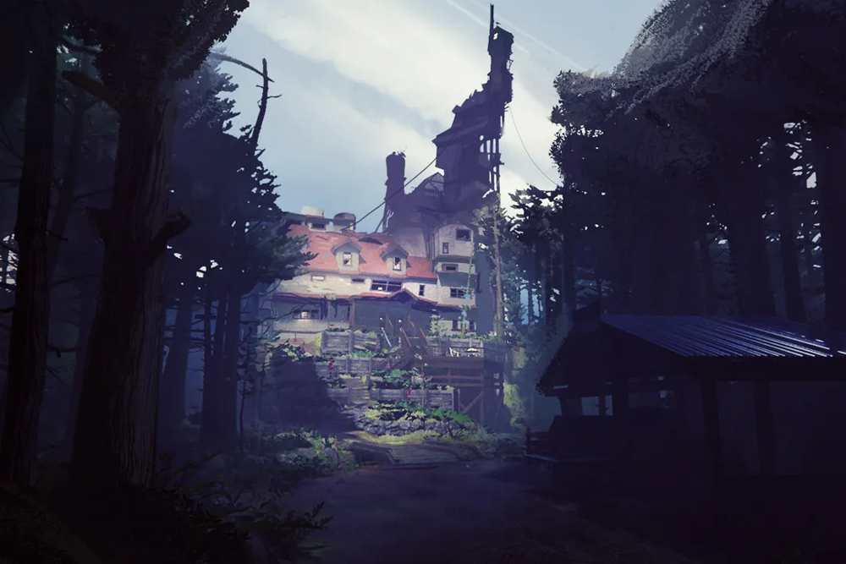
Figure: The haunted family home from What Remains of Edith Finch (2017). This title is often cited (with Gone Home) as a high-water mark of indie narrative games that blend melancholy with environmental storytelling. Wired describes the Finch house as “a mausoleum” of family memories[17] – every closed room contains diaries and relics of a deceased relative.
- What Remains of Edith Finch (Giant Sparrow, 2017) – A short narrative game in which the player explores the multi-winged home of the Finch family, learning through vignettes how each ancestor died. The aesthetic is quietly eerie: ordinary spaces become surreal tableaux. Wired’s Julie Muncy writes that Edith Finch’s vignettes often feel “gimmicky,” but when they work they “reveal a quiet beauty” in tragic stories[18]. Each scene is atmospheric – for example, one mini-game plays out in a child’s elaborately decorated “space fort” bedroom (see image below). The player, as teen Edith, reads journals and witnesses these short tales firsthand. Overall the game “aims … to tell a story about home, grief, and growing up”[19]. Its interest is not jump scares or combat, but empathetic immersion in the protagonists’ emotional states – a core liberal-gothic trait.
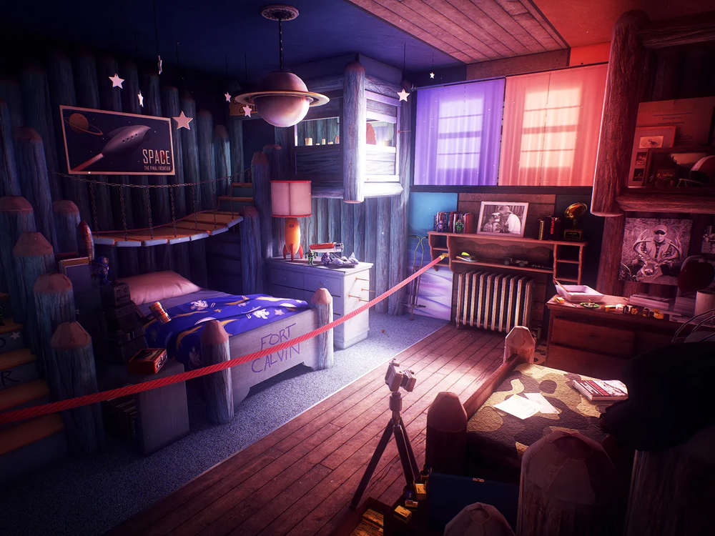
Figure: A child’s “space fort” bedroom from Edith Finch. In one vignette, this cheerful bedroom setting yields a devastating outcome, illustrating how Edith Finch uses mundane detail to evoke deep loss. Wired notes that each vignette “offers a compelling sketch of a person and a time” and can achieve “a quiet beauty” even in tragedy[18].
- Gone Home (The Fullbright Company, 2013) – A prototypical “walking simulator”: the player returns to an empty family home and learns the story of a teen’s coming-out and family tensions by finding letters and objects. There is no supernatural monster or murderer – the house itself is the main setting. As Wired points out, Gone Home started a “long line of games about empty houses,” with Edith Finch as its heir[20]. This design exemplifies liberal gothic’s narrative: there is no external antagonist, only the interior secret (a daughter’s affair with her best friend) and the emotional fallout. The player pieces together a personal story purely through environmental detail, highlighting mood and memory over plot twists.
- Rime (Tequila Works, 2017) – An adventure-puzzle game in which a boy and his dog explore a mysterious island filled with riddles. Ostensibly a fantasy story (inspired by The Little Prince), Rime is really about paternal grief: it was conceived as a meditation on a father’s processing of his son’s death. Critics note this explicitly: one writes that Rime contains “no more obsessive meditation on grief” in games[21]. The island’s puzzles and changing seasons symbolize the stages of sorrow. Gameplay is gentle (jumping, puzzle-solving) and cutscenes often show flashbacks of family. The impact comes from echoing the inner narrative: like all liberal-gothic works, Rime uses its mechanics and visuals to foreground the character’s inner world (in this case, the father’s guilt), rather than any external conflict.
Each of the above examples spotlights the liberal-gothic pattern: protagonists who are reflective “everyperson” types (often educated and sensitive), ambient and detailed settings, and narratives built around interiority and confession. As one reviewer notes, in these indie games the extraordinary (a witch’s curse, a giant monster) often serves mainly to amplify ordinary emotional truths. For instance, Edith Finch may have ghosts and curses, but it is above all a story of very human sadness (with a teenage narrator)[17]. Similarly, Rime’s fantastical island is simply the stage for a father’s acceptance of loss[21].

Comparative Table: Gothic Subgenres vs. Liberal Gothic vs. Indie Melancholy
Attribute | Liberal Gothic | Southern Gothic | Traditional Gothic | Prestige-Indie Melancholy
Protagonists | Educated, middle-class/liberal-leaning individuals (often white, urban or suburban) wrestling with personal trauma and guilt. | Rural Southerners or outsiders (often white, but sometimes Black or mixed-race) often of declining social status; frequently locked in generational or racial tensions[2]. | Often aristocrats, clergymen, or persecuted innocents (e.g. sympathetic heroines). Frequently foreign or historical settings; clear good/evil distinctions[1]. | Everyday or artistic characters (varied backgrounds, often college-aged or creative types) who feel disaffected or lost. Often culturally progressive milieus.
Emotional Tone | Introspective, confessional, often despondent. Emotions range from regret and yearning to panic and claustrophobic dread (“trauma dumping”). Pain is foregrounded. | Darkly ironic or cynical. Focus on moral anger, guilt, bitterness mixed with Southern pride. Often a blend of horror and gallows humor. | High on terror, suspense, and awe. Characters experience clear fear of uncanny forces; a sense of doom pervades. | Melancholic, reflective, bittersweet. Emphasis on subtle sadness, nostalgia, or quiet wonder rather than terror or anger. Often wistful or longing.
Narrative Function | Plot is minimal and serves the protagonist’s inner journey. Events chiefly trigger introspection or catharsis. (“Plot as pretext.”) | Plot often exposes hypocrisy, social decay or fate – revealing hidden truths about community or family. Violence tends to emerge to resolve moral conflict[2]. | Plot is driven by external threats (haunted castles, monsters, curses). The action and setting create horror; characters react to sinister events. | Similar to liberal gothic: plot is loose or episodic. Emphasis on character moments and atmosphere. Sometimes experimental or fragmented structures.
Aesthetic Devices | Mundane yet liminal settings (forests, empty houses, highways, suburban streets at night). Naturalistic visuals with emphasis on lighting and ambient sound. Dialogue is realistic and dry. | Iconic Southern settings (decaying plantation homes, swamps, small towns). Imagery of rot, ghosts of past (literal or figurative). Gothic elements (haunted mansions) merged with southern folklore. | Traditional Gothic tropes: medieval castles, abbeys, crypts, storms, religious iconography. Use of shadows, unknown corridors, creaking doors. Supernatural elements are explicit. | Art-house style cinematography or design: strong color palettes, stylized animations, or minimalist graphics. Realistic dialogue, indie rock/ambient soundtracks. Emphasis on mood.
Cultural/Political Valence | Encodes liberal/social-justice themes subtly (empathetic view of mental health, critique of patriarchy or capitalism by portrayal of individual suffering[3]). Focus is personal rather than systemic. Opposed by some as “trauma culture” that privatizes suffering[3]. | Often critiques Southern history (slavery, racism, patriarchy) and the romantic myth of the Old South. Some scholars note anxiety about labeling it Gothic (itself a “negative perception” of the South)[22]. Characters may rebel against or embody regional norms. | Traditionally apolitical in a modern sense: 18th–19th c. Gothic often expressed religious or anti-establishment anxiety (e.g. anti-Catholicism). Modern revivals may allegorize unknown fears (e.g. science) rather than specific politics. | Generally progressive or neutral; focuses on universal human experiences (trauma, identity, alienation). Less emphasis on overt ideology; when present, it’s often individualistic (e.g. “find yourself”). Critics cite indie melancholy as reflective of Millennial/Gen X sensibilities.
Reception | Often lauded by critics as mature, artful storytelling (e.g. Firewatch was a “critical darling”[23]). Successful works gain awards and strong sales despite niche format. However, some audiences and commentators dismiss it as navel-gazing or indulgent (the protagonist’s privilege is sometimes resented). | Long established as canonical (Faulkner, O’Connor, Morrison). Wins academic and critical respect for cultural insight, but has faced criticism (especially by Southern audiences) for reinforcing stereotypes of the South[22][2]. | Classic Gothic novels remain hugely influential and studied (e.g. Shelley’s Frankenstein is cited as defining the genre). In film, Gothic horror enjoys perennial popularity. Generally seen as a foundational genre, not niche. | Indie films/games often polarize: many critics celebrate their innovation and emotional depth (e.g. games like Gone Home and Edith Finch pioneered a genre[24][4]), but mainstream audiences may find them slow or “pretentious.” Commercially, they usually perform modestly yet can achieve cult status or awards.

Cultural Implications and Critiques
The rise of liberal gothic reflects broader cultural currents – particularly an emphasis on interiority and mental health. Advocates argue that these stories give language to contemporary anxieties and destigmatize therapy-like self-examination. For example, BoJack Horseman has been praised for showing depression “without filters… exactly as it looks when a person lives it”[10], suggesting the genre’s value in honesty. Independent games like What Remains of Edith Finch and Firewatch have been hailed as “some of the most thoughtful meditations on … life: love, loss, and grief”[4], indicating critical appreciation for their emotional sincerity. Indeed, many liberal-gothic works earn prestigious accolades and academic attention (one reviewer notes Firewatch’s narrative design is “studied to this day in games academia”[25]).
Critics, however, offer counterpoints. Some accuse liberal-gothic media of narrowness or “trauma culture” – prioritizing personal suffering over social analysis. Rob Horning (Noema) argues that modern “trauma narratives” often simply commodify individual anguish under a progressive guise[3]. In this view, the liberal-gothic focus on therapy and confession can obscure broader issues (e.g. economic inequality) by framing all problems as private sorrow. Similarly, skeptics note that protagonists are often privileged (well-educated, creative types), which can make the narratives feel parochial to some. The user’s critique (“whiny liberals … pathetic and cynical” media) echoes this backlash: if every story is about a liberal protagonist’s angst, it risks seeming self-absorbed or ideologically slanted.
In contrast, supporters argue these critiques underestimate the genre’s empathetic power. By immersing audiences in sincere, confessional storytelling, liberal gothic can foster emotional connection and catharsis. For example, Edith Finch’s vignettes encourage players to empathize with grief in granular detail[18], and A Ghost Story forces viewers to confront unresolved loss[13]. Even if the subjects are personal, readers and players often report profound impact. Commercially, the success of indie titles and prestige dramas suggests there is a market hungry for these narratives. The very term “prestige indie” implies critical and economic recognition. Critics have noted that such games and films may “soften us up for the … discipline of the commodity”[26] by turning personal trauma into narrative spectacle, but supporters counter that they also democratize storytelling by making emotion the subject of art.
Finally, liberal gothic’s cultural valence can be seen as ambivalent: it encodes liberal values (therapeutic discourse, progressivism) in its form and protagonists, yet it often refrains from explicit polemic. Political issues (race, class, etc.) are typically foregrounded only insofar as they intersect with individual psychology. Southern Gothic’s overt social critique contrasts with liberal gothic’s tendency to stay in the realm of feelings. Thus, while Southern Gothic authors like Flannery O’Connor used grotesque Southern backdrops to expose social ills (and sometimes recoiled at the label as unfairly demonizing the South[22]), liberal gothic often shifts blame inward. This inwardness is by design: the mode’s narratives suggest that by working through private wounds, individuals achieve some form of atonement or understanding. Critics and fans continue to debate whether this is therapeutic art or simply an indulgent spotlight on elite sensibilities.

Further Reading and Key Sources
Primary Texts and Media (examples):
- Novels: Hanya Yanagihara, A Little Life; Jonathan Safran Foer, Extremely Loud and Incredibly Close; Gail Honeyman, Eleanor Oliphant Is Completely Fine; Alice Sebold, The Lovely Bones. (See also classic Southern Gothic stories like Faulkner’s “A Rose for Emily” and O’Connor’s “A Good Man Is Hard to Find” for contrast.)
- Films/TV: Her (2013), A Ghost Story (2017), Take Shelter (2011), and the series BoJack Horseman (2014–20).
- Games: Campo Santo, Firewatch (2016); Giant Sparrow, What Remains of Edith Finch (2017); The Fullbright Company, Gone Home (2013); Tequila Works, Rime (2017).
Academic and Critical References:
- Jeffrey Weinstock, ed., The Cambridge Companion to American Gothic (Cambridge, 2005) – for foundations of Gothic and Southern Gothic.
- Christine H. Jones, ed., The Cambridge Companion to Gothic Fiction (Cambridge, 2007) – for general Gothic aesthetic[1].
- Catherine Spooner, Contemporary Gothic (Reaktion, 2006) – explores modern Gothic trends and can provide context for gothic revivals.
- Rob Horning, “The Problem with Trauma Culture,” Noema (Apr. 2024)[3] – a critical essay on “trauma narratives” and their political implications.
- Julie Muncy, “What Remains of Edith Finch Is a Great Game—If You See Yourself in It,” WIRED (May 2017)[17] – a journalistic review highlighting the game’s themes of memory and grief.
- Bee Wertheimer, “10 Years Later, Firewatch’s Critique of Masculinity Is Just a Different Shade of Toxicity,” AV Club (Feb. 2026)[23] – retrospective analysis of Firewatch’s narrative focus.
- Andrew Webster, The Art of Game Worlds (No Starch, 2017) – for background on narrative world-building in games.
- Stephen Kyffin, Gothic and Modern (Palgrave, 2019) – examines how Gothic evolves in modern fiction and media.
- Cathy Caruth, Unclaimed Experience: Trauma, Narrative, and History (Johns Hopkins UP, 1996) – foundational trauma theory (useful for psychological reading).
- Scott Bukatman, “Eternal Digital,” in Jeffrey Cohen, ed., Monster Theory (U. Minnesota Press, 1996) – on how monsters encode personal fears (conceptually relevant).
- Carol Margaret Davison, Gothic Fictions (Harper & Row, 1982) – classic analysis of Gothic tropes.
- Game Studies journals and proceedings (e.g. Game Studies, Convergence) – look for articles on narrative games (e.g. “Walking Simulators” or "serious games"). For example, Mimi Ito’s work on life simulation in games.
- Interviews and postmortems: (e.g.) Firewatch’s developer talks at GDC, or interviews with Rime creators on narrative design. These are often published on GDC Vault or game websites.
Notable Reviews and Essays:
- Wired’s coverage of narrative indie games (e.g. the piece on Journey and Edith Finch). See also The California Sunday Magazine’s article on “high-prestige indie games”[24].
- Electronic Gaming Monthly (Zackary Lieberman, “Future Departed: How Indie Games Grapple with Real-World Grief,” April 2017)[4] – a journalistic overview of grief in games.
- Critical reviews: Polygon, Kotaku, IGN feature articles on Life Is Strange, Gone Home, etc., that discuss emotional storytelling.
- Academic essays on Southern Gothic politics (e.g. articles in Southern Cultures) and on contemporary Gothic in popular culture (e.g. essays in Journal of American Culture).
These sources offer further context, analysis, and firsthand accounts to deepen understanding of how liberal gothic narratives function across media and what they signify culturally.

[1] Gothic fiction - Wikipedia
https://en.wikipedia.org/wiki/Gothic_fiction
[2] [22] The Evolving Southern Gothic: Traditions of Racial, Gender, and Sexual Horror in the Imagined American South
https://oaktrust.library.tamu.edu/server/api/core/bitstreams/3226b1e0-550f-4bb3-816f-0aec51a3addb/content
[3] [26] We Need To Decommodify Mental Health Care
https://www.noemamag.com/the-problem-with-trauma-culture/
[4] [21] The Future Departed: How Indie Games Grapple with Real-World Grief | EGM
https://egmnow.com/the-future-departed-how-indie-games-grapple-with-real-world-grief/
[5] Game Narrative Analysis - Firewatch
https://www.jaybroderick.blog/2016/11/game-narrative-analysis-firewatch.html
[6] [7] Book Review: A Little Life by Hanya Yanagihara
https://www.marleybetts.com/post/book-review-a-little-life-by-hanya-yanagihara
[8] [9] Review: Extremely Loud and Incredibly Close | literaryelephant
https://literaryelephant.wordpress.com/2018/09/11/review-extremely-loud-and-incredibly-close/
[10] The Anatomy of Failure: What BoJack Horseman Reveals about Ourselves - TheHumanist.com
https://thehumanist.com/arts_entertainment/culture/the-anatomy-of-failure-what-bojack-horseman-reveals-about-ourselves/
[11] Technology as a Human Affair: HER « I Like Things That Look Like Mistakes
https://moviescene.wordpress.com/2013/12/24/technology-as-a-human-affair-her/
[12] [13] Memory, Introspection, & Grief - A Ghost Story
https://www.whatsleepsbeneath.com/archive/a-ghost-story
[14] Take Shelter - Wikipedia
https://en.wikipedia.org/wiki/Take_Shelter
[15] [16] [23] [25] 10 years later, Firewatch’s critique of masculinity is just a different shade of toxicity
https://www.avclub.com/firewatch-10th-anniversary-toxic-masculinity
[17] [18] [19] [20] 'What Remains of Edith Finch' Review: It's a Great Game—if You See Yourself in It | WIRED
https://www.wired.com/2017/05/what-remains-of-edith-finch-review/
[24] The Art of Everything — The California Sunday Magazine
https://story.californiasunday.com/oreilly-the-art-of-everything/

